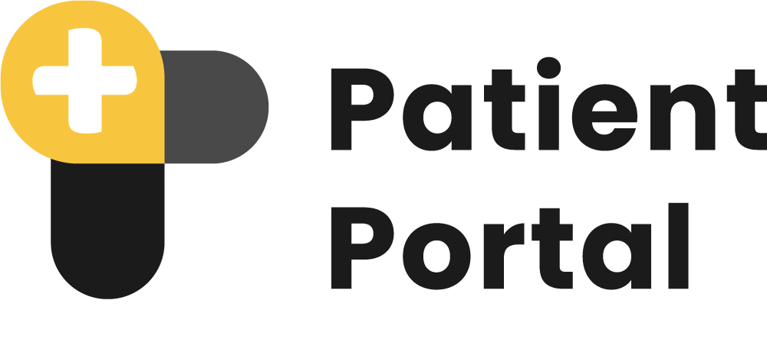
Share and access medical imaging data securely.

Application Landscape for Patient Imaging Portal

A Product of

Version 1.0
Document Control
Release No. | Date | Purpose/Change | Author
V 1.0 | Aug 21, 2024 | Initial Release | S M Al Shahaneaz Shaikat

Table of Contents
1. Business Purpose and Data Confidentiality 4
1.1. Data Confidentiality 4
1.2. The confidentiality and Security measures include: 5
2. User Level Access/Rights with Privileges Mapping 6
3. Architecture and Diagram 7
3.1. Mray Upload DICOM and Send Information via API 8
3.2. Patient Portal Site Registration and API Secret Key Generation 8
3.2.1 Patient Portal Generate New Patients & Orders 9
3.2.2 Display the Study in the Worklist 9
3.3 API Access for Receiving Mray Link 10
3.3 Hospital admin accessing Patient Portal through the Internet 10
3.3.1 Hospital admin accessing Patient Portal through Internet with Security Measures 10
3.4 Hospital/Site Admin access Copy or Print Link, or QR Code 11
3.6. Logging and Auditing 11
4. Application Landscape 12
4.1. Hospital Admin Workflow 12
4.1. Login to the Patient Portal 12
4.1. New Site Registration 12
4.1. Patient Portal Whiteboard 13
4.1. Patient Portal case on the whiteboard 13
4.1. Shareable link or QR code generator buttons on the whiteboard 14
4.1. Count of how many times a link or QR Code has been generated 14
4.2. Settings Options 14
4.2.1 Organization Setup 14
4.2.2 Update organization information 15
● General information 16
● API Settings page 16
● Workflow settings(MRay settings) 17
4.2.2 User List of Patient Portal 17
4.2.3 Adding new Users 18
4.2.4 Exam Information Page 19
4.2.5 Adding New Exam 20
4.2.6 Update Existing Exam 20
5. Technical Documentation 21
5.1 API Security 21

1. Business Purpose and Data Confidentiality
The primary business purpose of the Patient Portal is to facilitate seamless, secure, and confidential interactions between healthcare providers and patients. It is a platform for managing patient data, generating study orders, and sharing medical images through secure, shareable links or QR codes.

1.1. Data Confidentiality
Data confidentiality is paramount for the Patient Portal, especially given the sensitivity of health-related information such as patient records and DICOM files. To safeguard this data, the portal employs several industry-standard protocols and technologies:
- SSL/TLS: Secure Sockets Layer (SSL) and its successor, Transport Layer Security (TLS), are fundamental to protecting data in transit. This encryption protocol ensures that all data transferred between users' browsers and the server is encrypted and unreadable to anyone who might intercept it. This is crucial for securely transmitting sensitive patient data and medical images over the Internet.
- IIS: Internet Information Services (IIS) hosts the Patient Portal web server. Effectively configuring IIS to use SSL/TLS is essential for secure communications. This includes using solid ciphers, enabling HSTS (HTTP Strict Transport Security), and ensuring the server is up-to-date with the latest security patches.
- Certificate Management: Proper certificate management is vital for SSL/TLS deployment. The Patient Portal uses certificates from the trusted Certificate Authority “Let's Encrypt” to establish its legitimacy to end users. These certificates also use SHA-256 hashing algorithms for robust security.
- Role-based access control (RBAC): Patient Portal follows the RBAC security model, which assigns permissions based on user roles within an organization. This approach ensures that only authorized users access specific resources, enhancing security by minimizing unauthorized access and data breaches. RBAC streamlines permission management, makes auditing easier, and helps prevent privilege escalation by aligning access rights with job responsibilities.
- API Security
The Patient Portal API employs multiple security measures to ensure safe and authorized access to its features. API Security measures include:
- Basic Authentication: Each API request includes a Basic Auth header, which includes a Base64-encoded string representing the username and password. This method helps prevent unauthorized access to the API and ensures that interactions are secure.
- API Secret Key: In addition to Basic Authentication, a Secret Key is required for all API interactions. This key acts as an additional layer of security, ensuring that only requests from authorized sources are accepted. The Secret Key must be included in the header of each API request, providing a second verification step to secure API access further.

2. User Level Access/Rights with Privileges Mapping
The Patient Portal implements a Role-Based Access Control (RBAC) system that defines specific access levels based on the user’s organizational role. Below is a high-level outline of user access levels and their respective privileges:
User Role | Access Level | Privileges
Super Admin | Full Access | - All site access  - Site signup approval  - Create a new site  - View all site information
Site Admin | Single Site Full Access | - Manage a single site settings and configurations  - Access to all patient records, studies, and user activity logs  - Grant/revoke permissions for other users
API User | API Request | - Order Create  - Link Request

3. Architecture and Diagram
The following application landscape outlines the interaction and data flow between various components within the Patient Portal system, incorporating the exchange of DICOM data, patient information, and API integrations. This landscape enables a seamless workflow from initiating a study in Mray to managing and distributing medical data in the Patient Portal.

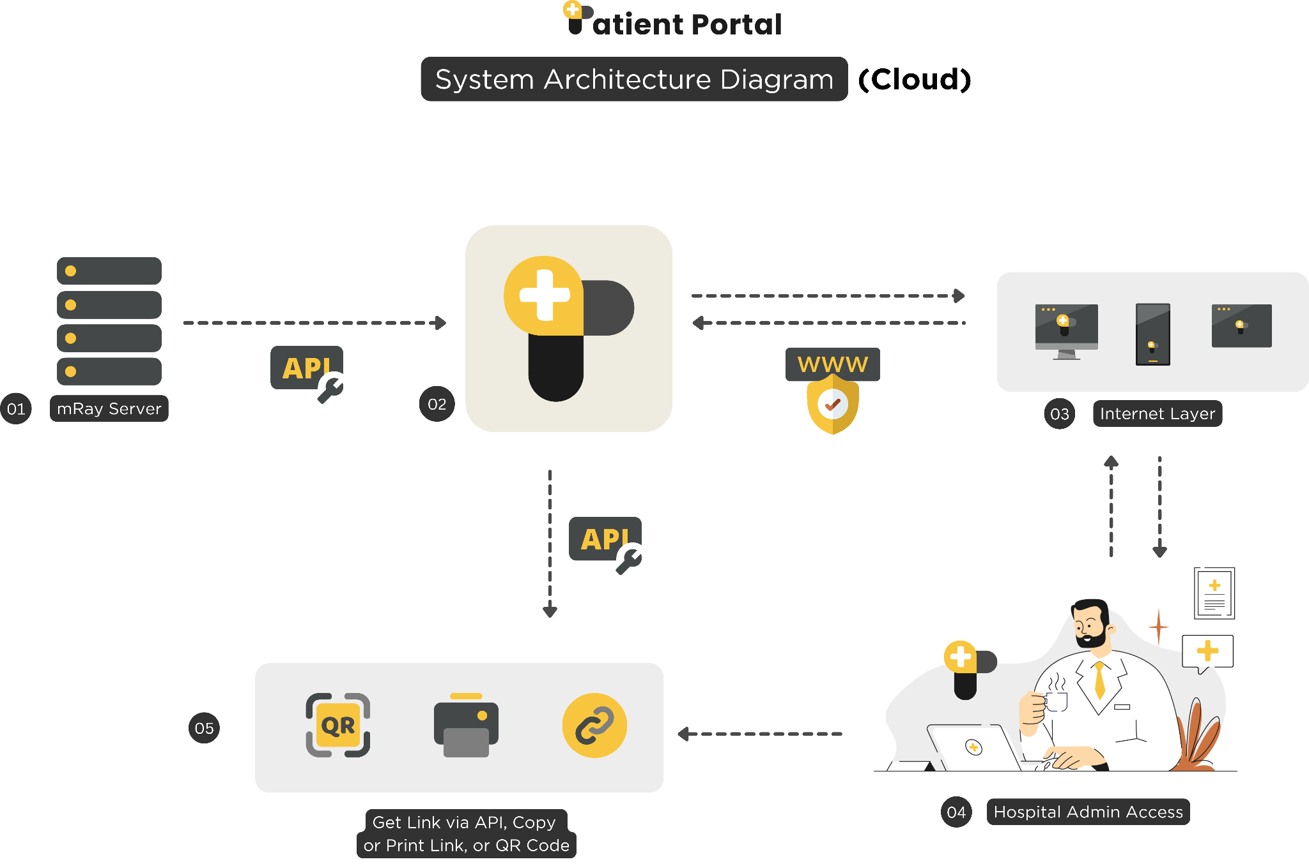

3.1. Mray Upload DICOM and Send Information via API
Objective: Initiate the collection of patient data, study information, and DICOM files.
- Upload DICOM files and use the API to transmit site, patient, and study information to the Patient Portal.
Actions:
- Begin by collecting patient demographics and study details.
- Prepare DICOM images for upload.
- Upload DICOM images to Mray's server.
- Send an API request to the Patient Portal, including:
  - Site Information: Clinic or hospital identification
  - Patient Information: Name, age, medical history
  - Study Information: Modality, study details, physician name
Outcome: DICOM files and related information are securely sent to the Patient Portal.

3.2. Patient Portal Site Registration and API Secret Key Generation
- Objective: Register new sites and generate API Secret Keys for secure data exchange.
- Actions:
  - Site administrators complete the sign-up process in the Patient Portal.
  - The Patient Portal generates a unique API Secret Key for each new site.
  - The key is provided to the site for future interactions with the Patient Portal.
Outcome: New sites are registered, and secure API keys are generated for data transmission.

3.2.1 Patient Portal Generate New Patients & Orders
- Objective: Automatically generate new patient profiles and study orders based on information received from Mray.
- Actions:
  - The Patient Portal creates new patient profiles using the information provided by Mray.
  - A new order is generated, detailing the study and linking it to the patient profile.
  - The system generates a unique Mray Link and QR Code associated with the study.
Outcome: New patients and orders are created and linked to their respective studies. A Mray Link and QR Code are generated.

3.2.2 Display the Study in the Worklist
- Objective: Display the newly created patient profile, study details, and Mray Link/QR Code in the Patient Portal's worklist.
- Actions:
  - The system displays the new patient and study order in the worklist.
  - The associated Mray Link and QR Code are available for quick access and sharing.
Outcome: The patient’s study is visible in the worklist, with the Mray Link and QR Code available.

3.3 Secure Access to the Patient Portal through the Internet
Objective: Ensure secure access to the Patient Portal while protecting data integrity.
Actions:
- SSL/TLS Encryption: Implements SSL/TLS protocols to encrypt data in transit, securing sensitive patient information and medical images.
- IIS Configuration: The Patient Portal is hosted on IIS with strong ciphers, HSTS enabled, and regular security updates to ensure safe communication.
- Certificate Management: Uses trusted SSL/TLS certificates from Let’s Encrypt with SHA-256 hashing for secure and legitimate connections.
Outcome: These measures protect data access and ensure secure interactions with the Patient Portal.

3.4 Hospital/Site Admin access Patient portal to Copy or Print Link or QR Code
Objective:
Provide hospital/site administrators with the ability to copy or print the QR code and shareable link associated with specific patient studies directly from the patient portal.
Actions:
- Navigate to the specific patient study in the Patient Portal.
- Use the interface options to select the desired QR Code or link.
- Choose the 'Copy Link' option to copy the link to the clipboard for digital sharing.
- Select the 'Print QR Code' option to generate a physical copy of the QR Code for patient handouts or physical records.
Outcome:
Hospital/Site Administrators can efficiently manage and distribute access to patient studies through the Patient Portal, copy or Print Links, or QR Codes.

3.5 API Access for Receiving Mray Link
Objective: Allow external systems and authorized users to access the Mray Link and study information via the API Secret Key.
Actions:
- For every authorized user or External System, an API Secret Key is generated.
- External systems request the Mray Link via the Patient Portal's API using the API Secret Key.
- The API provides access to the Mray Link and QR Code.
- Every access request is logged, including the number of times the study link has been shared or accessed via API.
Outcome: Authorized users can retrieve and share study links securely. All interactions are logged for auditing purposes.

3.6. Logging and Auditing
Objective: Track all user interactions in the Patient Portal
Actions:
- Log the number of requests for Mray Links or QR codes.
- Record user activity, including timestamps and actions related to the access and sharing of study data.
Outcome: All interactions with study links are logged

4. Application Landscape

4.1. Hospital Admin Workflow

4.1. Login to the Patient Portal
Access the portal by visiting https://myimagingportal.com.
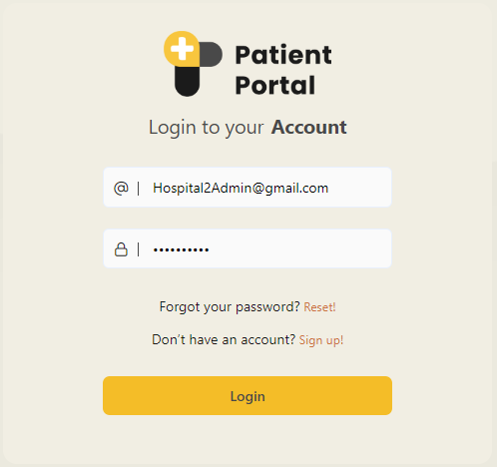

4.1. New Site registration
To register for a new site, click the Sign Up! button, which will take you to the signup page.
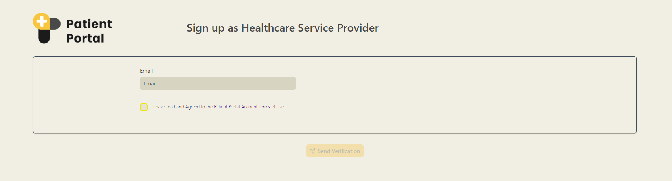

4.1. Patient Portal Whiteboard
After logging in, you should see the Patient Portal whiteboard.
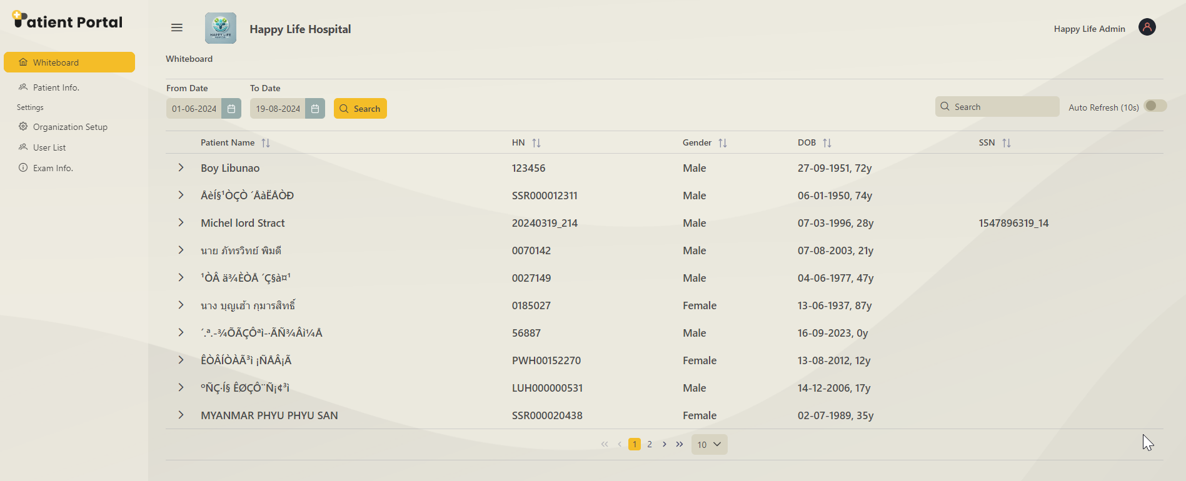

4.1. Patient Portal case on the whiteboard
Clicking on the arrow button lets you review a case in detail.
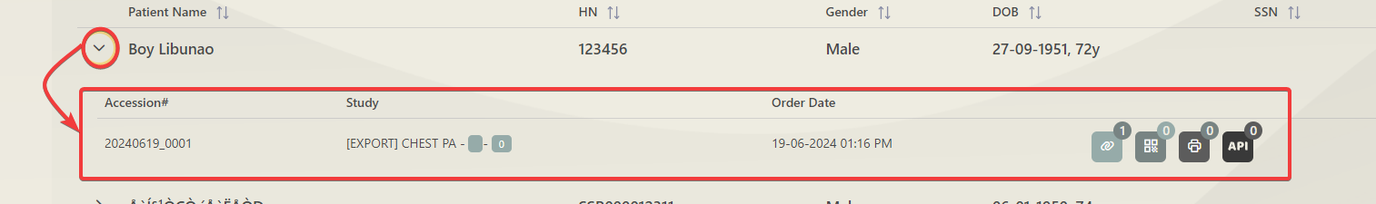

4.1. Shareable link or QR code generator buttons on the whiteboard
In the dropdown, the shareable buttons are accessible
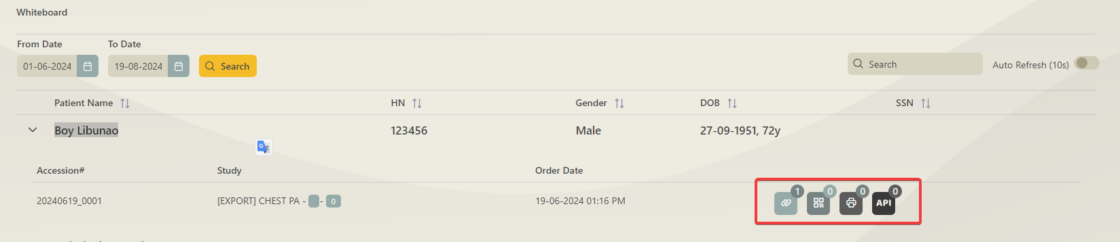

4.1. Count of how many times a link or QR Code has been generated
A shareable link and QR code can be generated from here. You can also print the QR code from here. Here, you can see the number of times a link has been clicked.
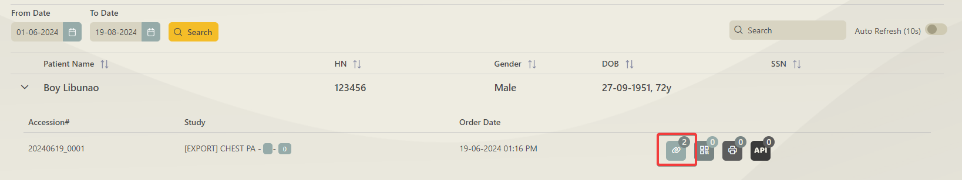

4.2. Settings Options

4.2.1 Organization Setup
This page displays all the existing organizations. You can also update organization information on this page.
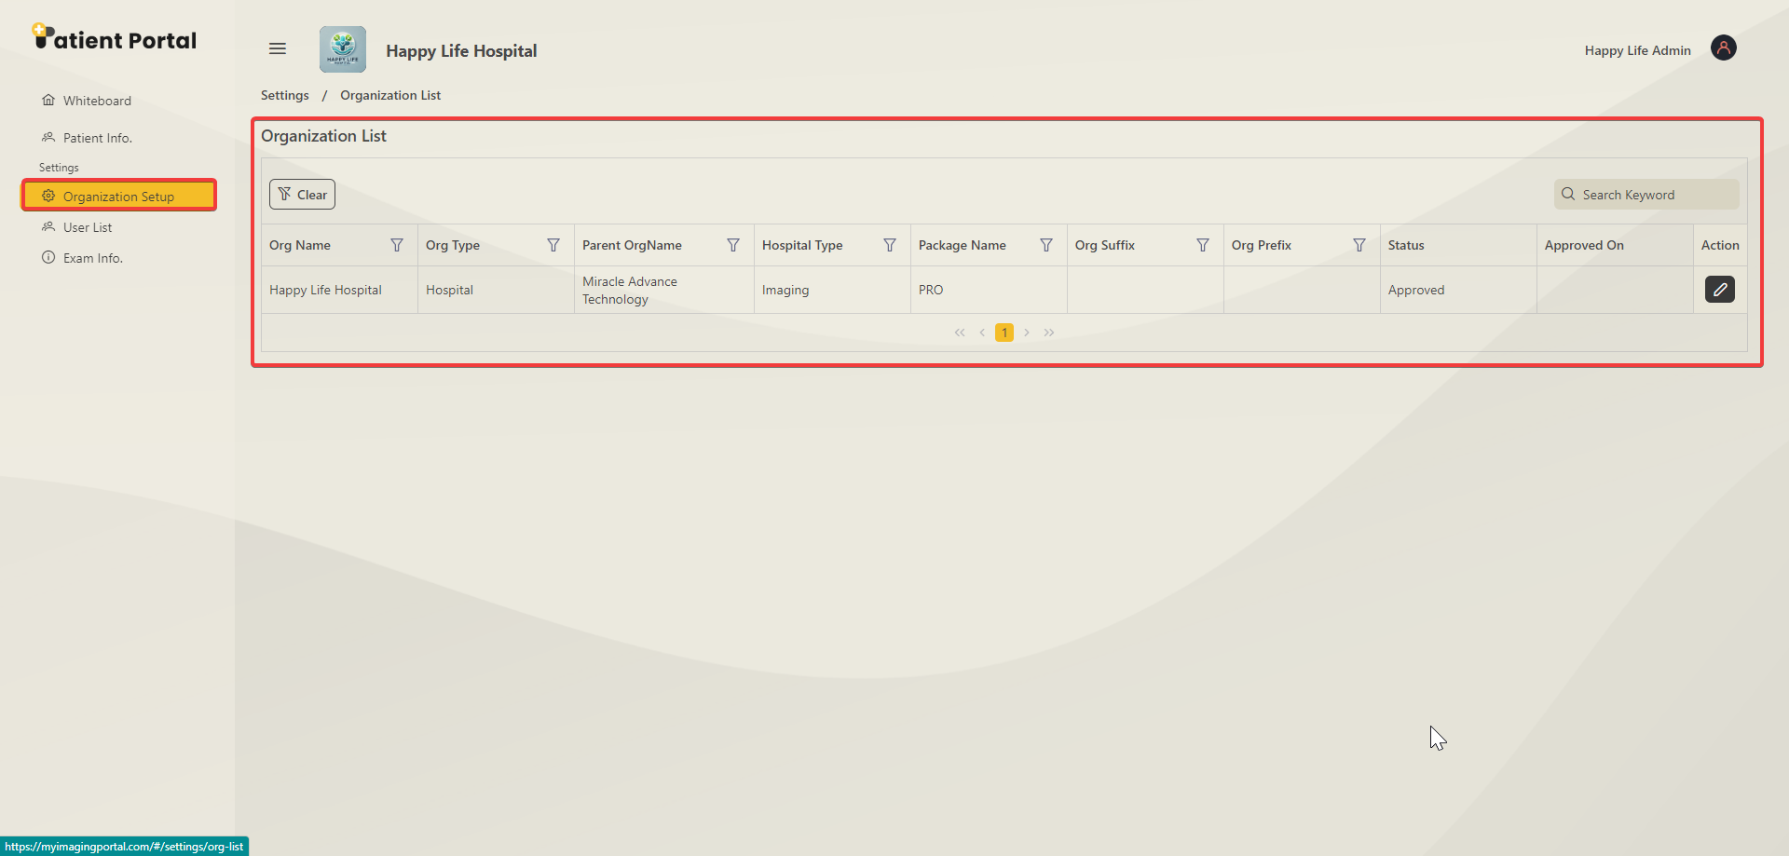

4.2.2 Update organization information
When the update button is clicked, a popup page appears, and you can update the general information, API settings, and workflow here.

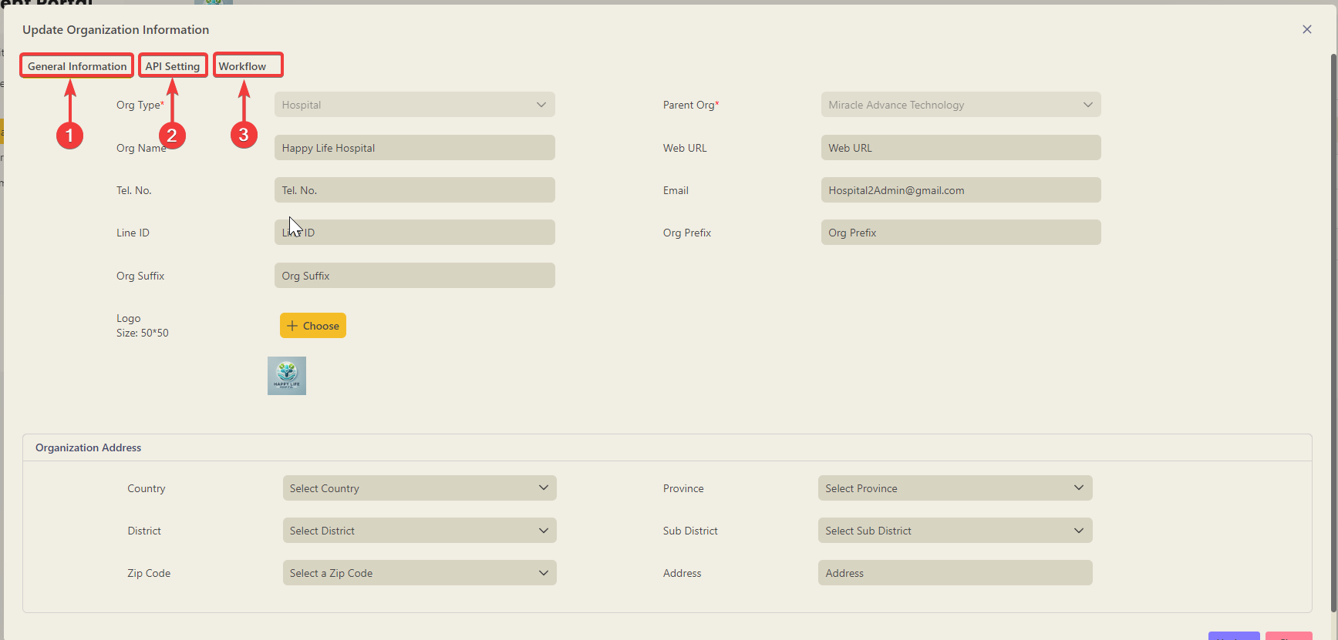

General information
The general information page lets you update the Information and address of the organization.
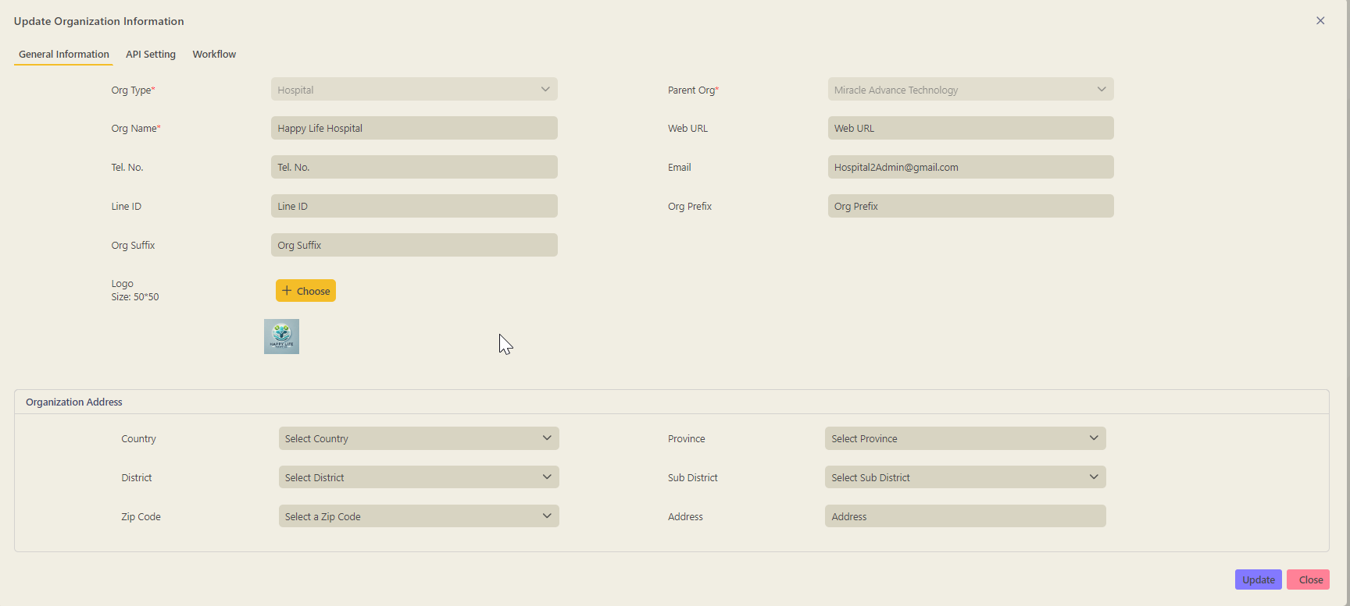

API Settings page
All incoming and outgoing APIs for a specific organization can be updated here.
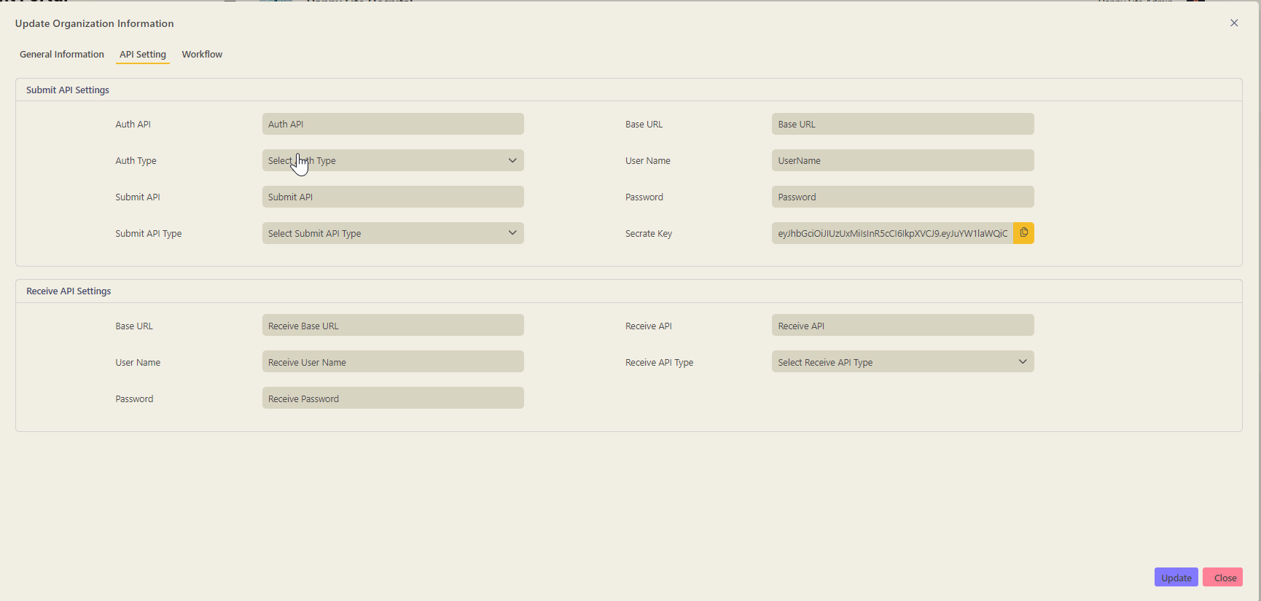

Workflow settings(MRay settings)
All the MRay settings can be added or updated from this page.
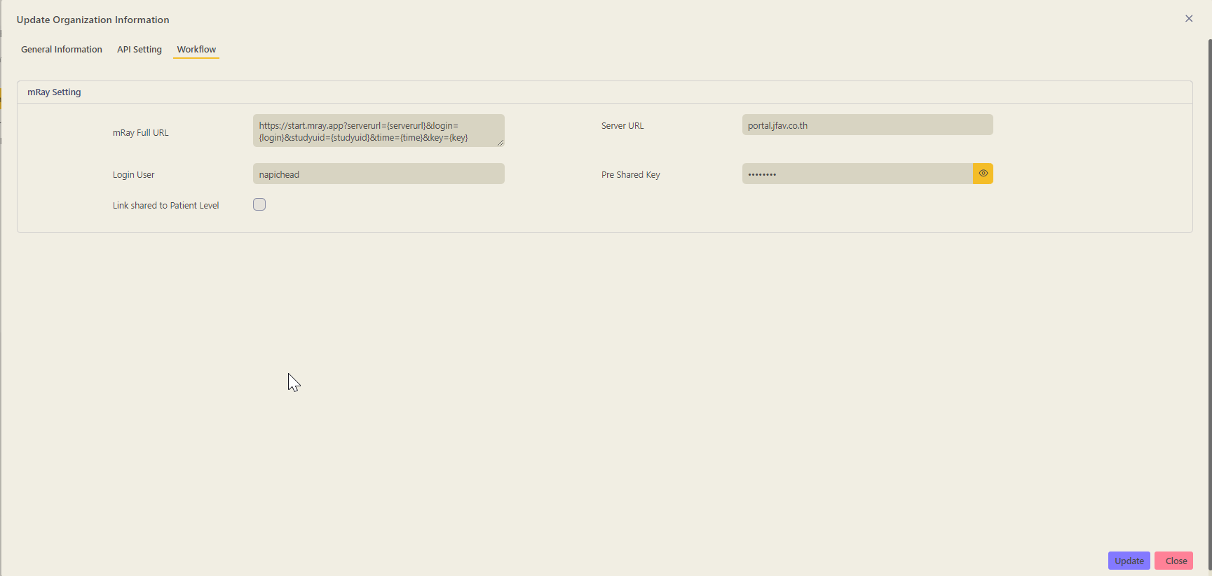

4.2.2 User List of Patient Portal
All the users or roles can be reviewed, added, removed, or updated on this page.

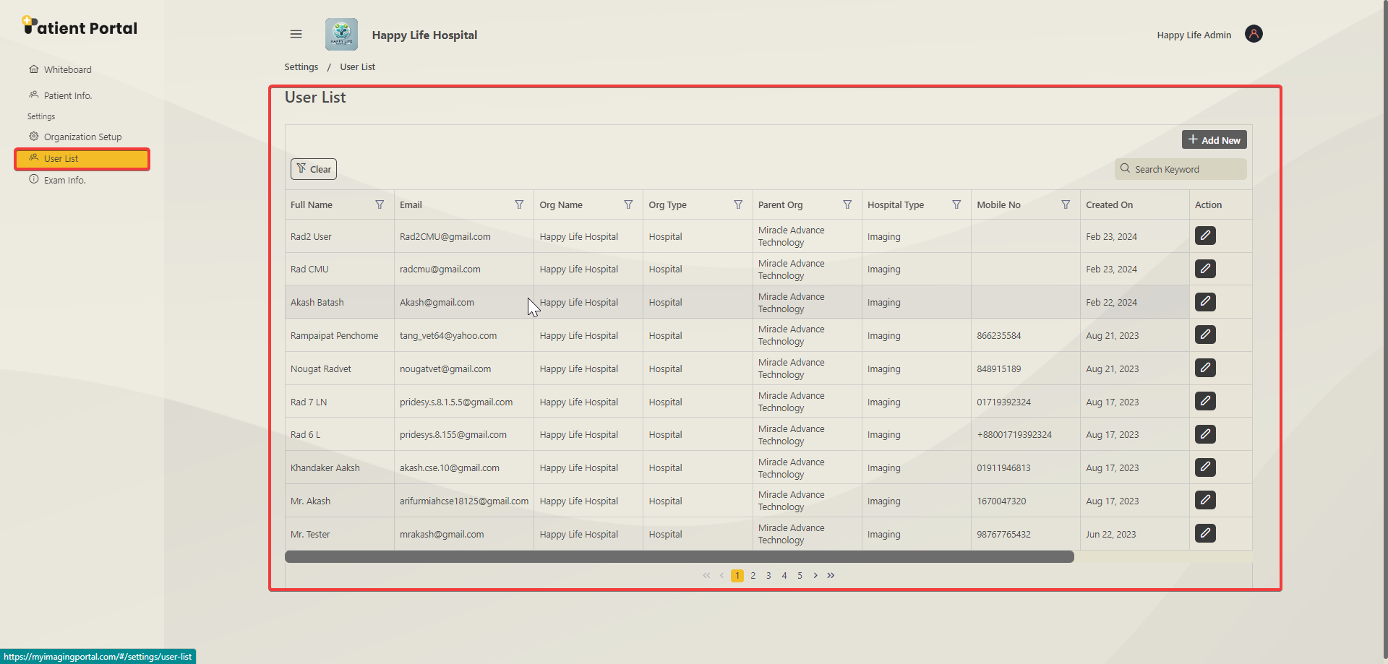

4.2.3 Adding new Users
A new user is added by clicking on the Add New button.
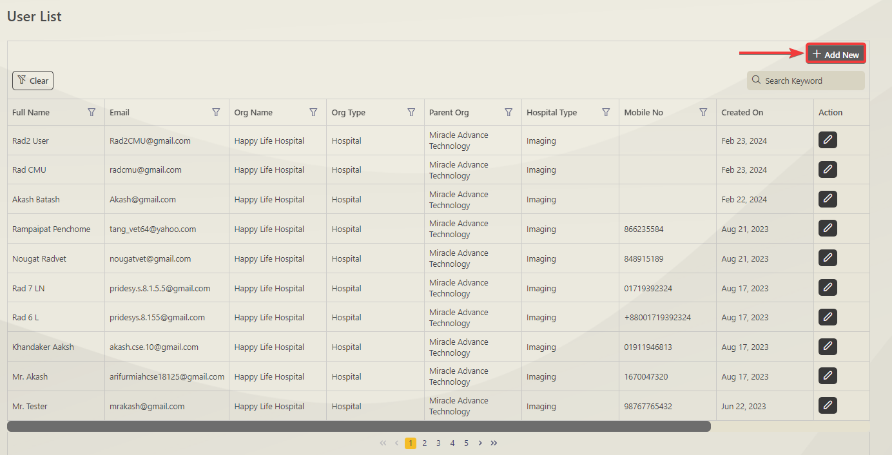

After clicking, an add new user page pops up. Before submitting the form, you must fill in all the information marked with a Red Asterisk(*).

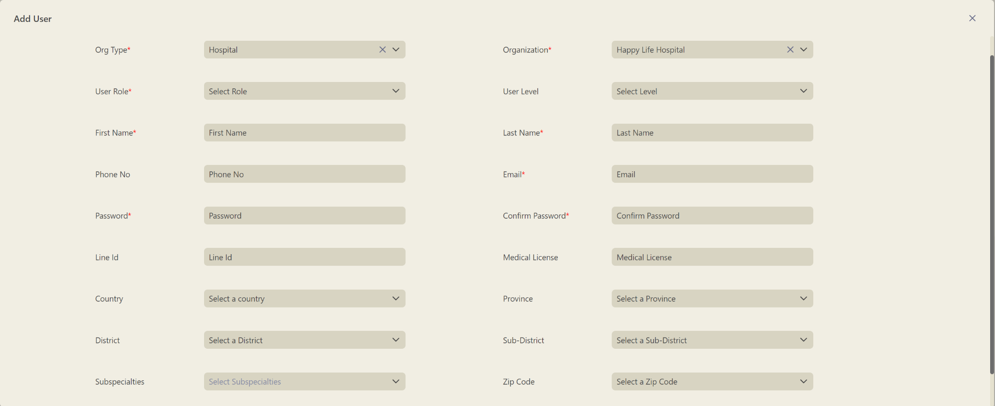

Update Existing Users
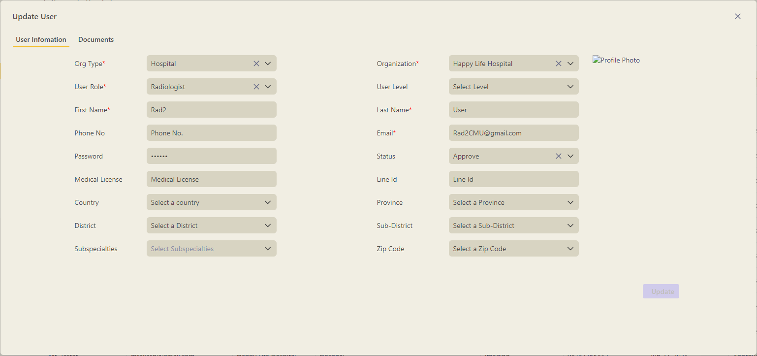

4.2.4 Exam Information Page
All the exams can be mapped and configured on the Exam information page.

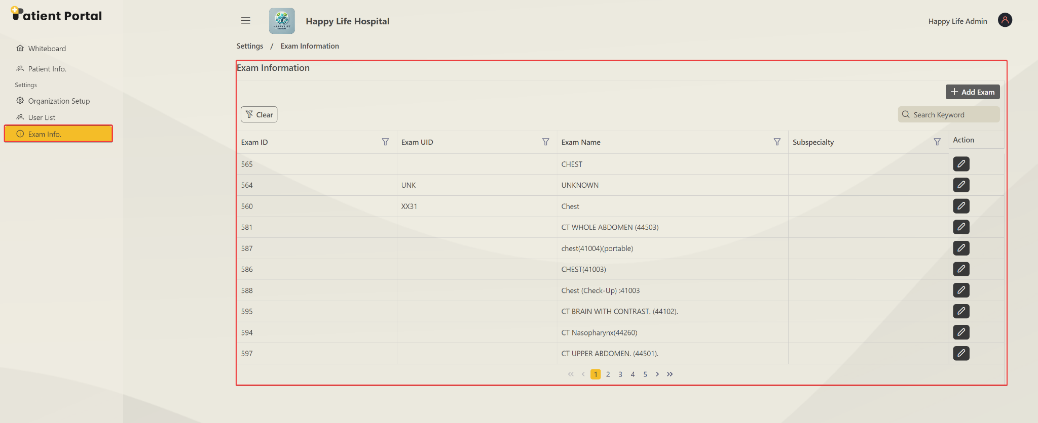

4.2.5 Adding New Exam
A new exam can be added. After clicking the Add Exam button, you should see a popup window where you can add the name UID and Subspecialty for the new exam.

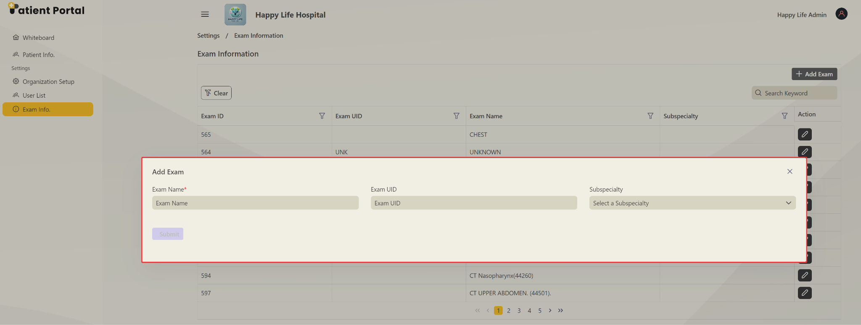

4.2.6 Update Existing Exam
The exam can be updated by clicking on the edit button.

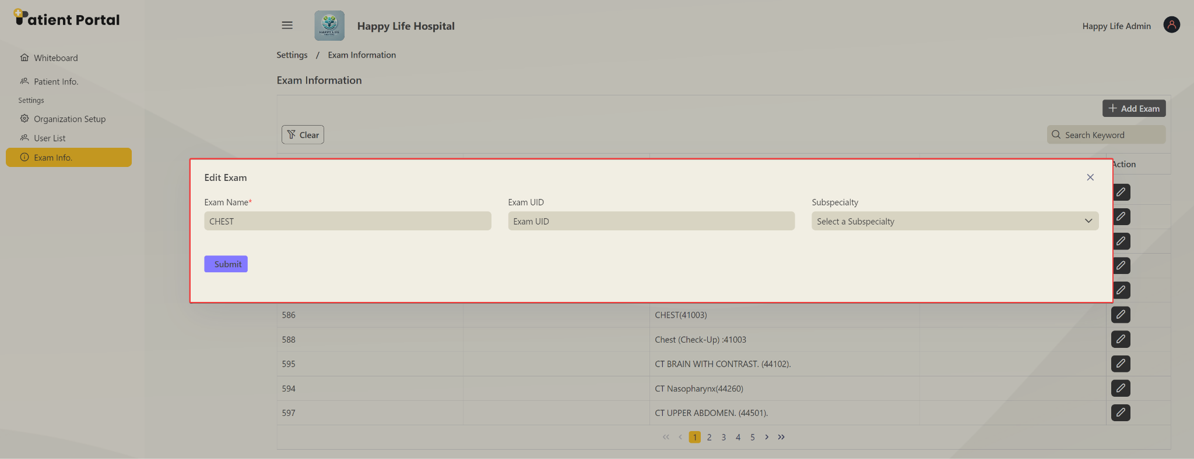

5. Technical Documentation
This section provides detailed API documentation, outlining how to create imaging orders and share links and QR codes through the Patient Portal API. It also covers the security measures implemented to protect these interactions.
Please refer to the document for API documentation on creating imaging orders and sharing links and QR codes - Patient Portal API Documentation

